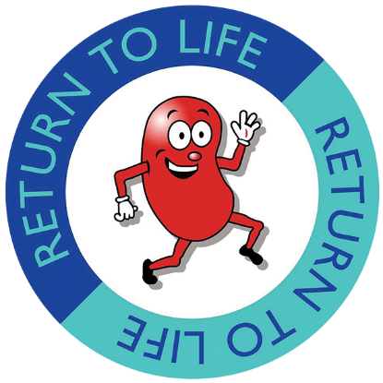
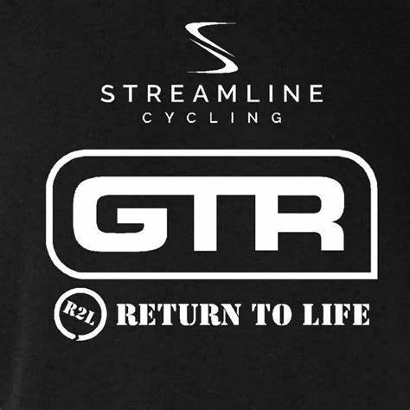

GTR Return to Life P/b Streamline M101 TT
Charity TT
04/06/2023
Organiser- Terry Wilkinson
07769152563
Gtr.tw88@gmail.com

Promoted for & on behalf of Cycling Time Trials under their rules & regulations
HQ
Ormston St
East Hartford
Cramlington
NE23 3BE

Sign on from 07:00am

The HQ is located just off the Barnesbury 10 course at the football club. There will be plenty of parking for riders at the club. However, for those that want to park elsewhere, there is the 3 horse shoes pub located just off the roundabout near the start line. All that I would as is that you respect the locals when parking and don’t block any entrances into the horse fields.

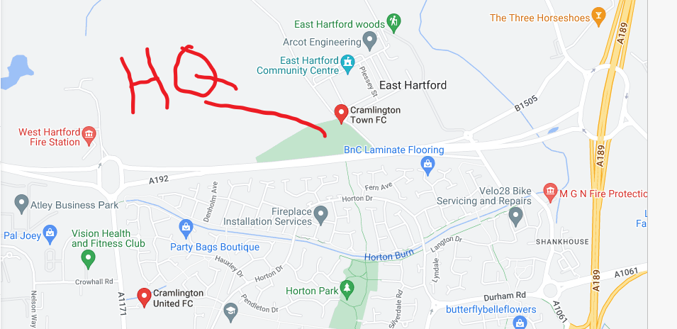

Time Keepers
Start- Peter Schultz
Finish- Francis Schultz and Sharon Dyson

The time keepers will get the results sorted as quickly as possible. Please don’t pester them when they are trying to sort results. Remember, the TK decision is final. Strava is not a time keeper.

The course
This course is the 10 course being used for this year’s RTTC national 10. So for those who fancy entering it in September, this is the perfect opportunity to get an idea of what to expect. Please be aware it is about a 5 minute ride to the start line from the HQ so make sure you leave in good time.

START at the beginning of Church wall on Bedlington road (B1505). Proceed to the Three Horseshoes roundabout (0.295m), taking the first exit onto the A189 northbound. Proceed to the North Seaton (Sandy Bay) roundabout, encircle (riders take care) and retrace to FINISH on slip road to A192 opposite the metal post.

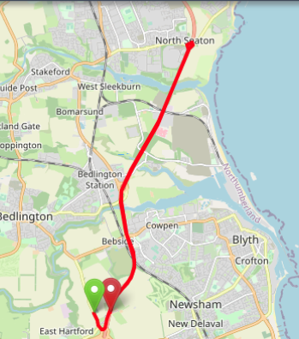

Safety notes

Vehicles of competitors / officials / marshals / helpers to be parked safely and without hindrance to other road users.
No U-turns to be made in the vicinity of the timekeepers
Please be considerate to those on the course and racing.
Remember 2017 regulation to sign-off and return number, failure to signoff may result in DNF
All riders are responsible for their own safety
You must obey the rules of the road and obey all traffic signs, signage and direction indicators
- It is your responsibility to ensure that your machine is roadworthy and that you ride safely at all times
- You must look ahead and not ride with your head down
- You must not take pace or shelter from any other vehicle or competitor (no drafting)
- Failure to comply with any of the above may lead to disciplinary action being taken
- No warming up on the course once the race has started

Hard shell helmets are now compulsory for all riders.
A working rear red light and front white light are compulsory for all riders. No lights, no ride.
Road Category
There will be a road category for this event. Please sign the separate sheet if you wish to qualify for this. The following rules must be followed to qualify for this category-
- skin suits are allowed
- No TT bars
- NO wheels deeper than 90mm

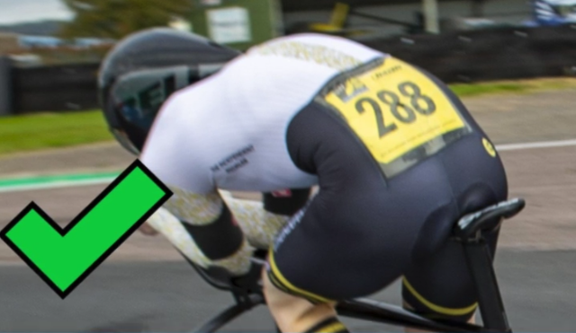
This is good placement for the numbers. Please put them in a position that the Time Keepers can see them.

The race and the cause
This TT event is being run to raise money for the charity “Return to Life”. This is a small local renal charity based in Paisley, Scotland. It supports those who suffer from chronic Kidney disease, on Dialysis and pre and post-transplant.
It provides guidance for those just starting off the journey as newly diagnosed renal patients. It is a gateway to provide access to social security benefits, help completing forms, understanding the condition, employment rights and financial grants. Over the last few months the charity has seen an increase in those struggling with energy bills to maintain heating. This is something the charity has helped with. The charity can supply heated blankets to those struggling. As well as other items where required.
This race will not have any prizes for winners. All funds minus the usual finances required to run a race will be donated to the charity. Thank you all for entering the race. The money will help to make a difference to those that need the support.

There will be no refreshments put on for the race as it’s so early in the morning and the money will be put into the charity.

Finally, thank you for entering the race. Hopefully it will be a great day for all with some decent times. Please don’t hesitate to get in touch if you have any questions. Look forward to seeing you all on the day.

Cheers
Terry

